1. The structure shown below is an intermediate in the mechanism of electrophilic aromatic substitution of chlorine with aniline. Draw three additional resonance structures for this intermediate. Identify the lowest energy resonance structure by writing the appropriate letter on the line provided.



**A** **B C D**

Lowest energy: _______

2. For the drug levonogestrol shown below, circle all functional groups present and label each with a letter (a, b, etc.). Use the table provided to name each of your labeled functional group. (Note: the number of rows provided in the table has no meaning!)

|  |  |
| --- | --- |
|  |  |
|  |  |
|  |  |
|  |  |
|  |  |
|  |  |

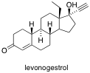

3. Students in an organic chemistry lab are conducting an experiment to determine the outcome of an electrophilic aromatic substitution reaction of anisole. The students predicted three possible products, compounds **X, Y,** and **Z**. Rank the products in order of decreasing melting point.

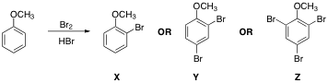

______ ______ ______

4. The compound 4-methoxybenzoic acid is very soluble in water, but 4-chlorobenzoic acid is only minimally soluble in water. Explain this observation in **no more than two sentences**. Any writing beyond two sentences will not be graded. (Hint: You can use a depiction involving a few water molecules and either or both of these structures to illustrate your point.)

