THEATRE – KINDERGARTEN
Body, Voice and Imagination

The Actor's Tools
Lesson 1

Content Standards
1.1 Use the vocabulary of theatre, such as actor, character, cooperation, setting, the five senses, and audience, to describe theatrical experiences.
2.1 Perform imitative movements, rhythmical activities, and theatre games (e.g., freeze, statues, and mirrors).

TOPICAL QUESTIONS
- How does an actor use the body, voice and imagination to create theatre?
- How do I define actor and character?

OBJECTIVES & STUDENT OUTCOMES
- Students will demonstrate appropriate call and response using their voice (loud and soft), body. (strong and smooth) and imagination to create theatre.
• Students will create movement related to theatre.

ASSESSMENT
- Feedback for Teacher
  - Student observation
  - Answers to Inquiry
  - Teacher rubric and scoring template (included)

- Feedback for Student
  - Teacher feedback
  - Peer feedback on performance

WORDS to KNOW
- actor: a person, male or female who portrays a character
- character: personality or part an actor recreates that can be real, imaginary, or magical
- audience: people who actively watch, listen and respond to live theatre
- volume: degree of loudness or intensity of a voice
- imagination: The ability to visualize and create a reality.

MATERIALS NEEDED
- Cards with illustrations of animals or activities (included)
- Teacher rubric and scoring template (included)
- Optional: music for performance
RESOURCES
- SDCS VAPA Core Learnings

WARM UP (Engage students, access prior learning, review, hook or activity to focus the student for learning)
• Introduce yourself. (e.g., “I am Mr. Jones.”)
• In general space, and without touching anyone or anything, students walk around the room and stop in front of another student.
• Students exchange names by saying “I am ______,” and the responding student says, “Hello ________, I am _______”.

MODELING (Presentation of new material, demonstration of the process, direct instruction)
Part 1
• Arrange students into a circle and explain that students will communicate their name using only a movement.
• Make the movement very strong, like stomping a foot and pounding the arms and hands.
• Lead students through practicing the strong motion several times: (e.g., stomp, pound, etc.)
• Say your name while doing the movement. (e.g., stomp and say Mrs. Smith)
• Keep the rhythm even and ask students to say their names, one at a time taking turns around the entire circle using strong, loud voices (volume) with strong movements.
• Do not allow screaming.

Part 2
• Create a movement that is soft, gentle and flowing like making an arm wave that travels across the body.
• Lead students through practicing the soft waving motion several times.
• Now say your name while you do the movement. (e.g., wave and say Mrs. Smith)
• Lead students, one at a time going around the entire circle keeping the rhythm even.
• Ask students to say their names, in soft and flowing voices while doing soft and flowing movements.
• Do not allow whispering.

Part 3
- Challenge students to use a soft movement with loud volume.
- Challenge students to use a strong movement with quiet volume.

GUIDED PRACTICE (Application of knowledge, problem solving, corrective feedback)
Activity 1
- Give students the definition of actor, character and imagination. This can simply be stated as: an actor is a person who pretends to be someone or something else by using their voice, body and imagination.
- Ask students to think of an activity they really like to do OR choose an animal they really like.
- Either prepare cards with illustrations of animals or activities (illustrations included) or verbally give suggestions of familiar animals and activities the students can act out.
• Activities could include playing a sport, (e.g., baseball, swinging a bat; soccer, kicking a ball, dancing, running, swimming, swinging, etc.) or animals (e.g., elephant, cat, dog, monkey, mouse, etc.)
- Have students identify whether the animal or activity would have loud or soft volume, and strong or smooth movements.
• Give the students time to explore playing that activity or moving like that animal.
• Allow students to use their voices to make sounds that are appropriate to the animal or activity (look for appropriate volume and sound for the animal or activity, confidence, bravery vs. shyness, overall use of imagination).
Activity 2
• Divide the class into four smaller groups.
- Explain the role of the audience. Reinforce the role of audience throughout this exercise.
• Each individual in group that performs will introduce themselves (speak their name) and perform their activity or animal as a group. (There may be less anxiety to perform in a group).
• Optional: You can play appropriate music for background.
• Allow one minute for movement and two-three minutes for the audience to guess what the group was doing.
- Have the audience identify if the actors used loud or quiet volume and strong or soft movement. Ask if the volume and movement used helped the audience guess the animal or activity.
• Switch groups.
• The rest of the class will act as a good audience. (e.g., watch, applaud and respond appropriately.)
• After each performance, ask the audience what they thought the students were doing. (e.g.,”Guess what activity the actors enjoy or what animal they were.).
• Repeat until all four groups have had a turn.
- Evaluate student work using the attached rubric.

DEBRIEF & EVALUATE (Identify problems encountered, ask and answer questions, discuss solutions and learning that took place, did students meet outcomes?)
- “What did you notice about the relationship between a loud voice and strong movement?” (Loud voice and strong movement work well together).
• “What did you notice about the relationship between a soft voice and gentle movement?”
(Soft voice and gentle movement work well together).
- Ask students to do a strong movement with a soft voice, and a soft movement with a strong voice. (These are opposites and don't work well together).
• “What was challenging about doing the opposite body movement from the vocal sound?”
- “What have you learned about body energy and vocal energy?” (That the energies must match)
• “When are loud voices appropriate?”
• “When are soft voices appropriate?”
• “How can we communicate what we want without speaking?”
- Evaluate student work using the attached rubric.

EXTENSION (Expectations created by the teacher that encourage students to participate in further research, make connections, and apply understanding and skills previously learned to personal experiences)
Ideas:
• Students create sound effects for three to five objects. (e.g., an electric toothbrush, a video game, electric pencil sharpener, telephone tones, vacuum cleaner, hair dryer, electric saw or tool, etc.)
• Ask students to recall when they have used loud and soft voices in their home.
- Show the animal illustrations in this lesson to students.
  - Ask them to demonstrate what the voices might sound like (loud or soft) and what the movement might be like for the characters represented.

Teacher Rubric and Scoring Template for Lesson #1

Scale 3: Proficient 2: Basic 1: Below Basic

Criteria:
3 = Movement, voice, and imagination is strong, confident and clearly represents the animal or activity.
2= Movement, voice, and imagination is moderately represented. The animal or activity is recognizable. Mimicking others’ ideas might be demonstrated.
1= Movement, voice, and imagination is unclear in more than one area. Student does not demonstrate independent choices.

Student Name ______________________________________

Animal Choice or Activity | Use of Body  3 2 1 | Use of Voice  3 2 1 | Imagination and Confidence  3 2 1
Animal Selected | Notes  Score | Notes  Score | Notes  Score
Activity Selected | Notes  Score | Notes  Score | Notes  Score

Teacher Rubric and Whole Group Scoring Template for Lesson #1

Scale 3: Proficient 2: Basic 1: Below Basic

Criteria:
3 = Movement, voice, and imagination is strong, confident and clearly represents the animal or activity.
2= Movement, voice, and imagination is moderately represented. The animal or activity is recognizable. Mimicking others’ ideas might be demonstrated.
1= Movement, voice, and imagination is unclear in more than one area. Student does not demonstrate independent choices.

Place notes and score in each box
Name | Animal Choice or Activity | Use of Body  3 2 1 | Use of Voice  3 2 1 | Imagination and Confidence  3 2 1

Animal Illustrations

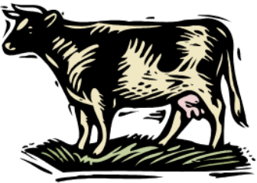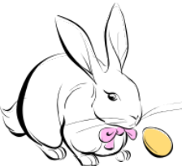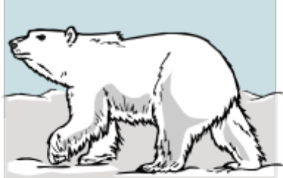

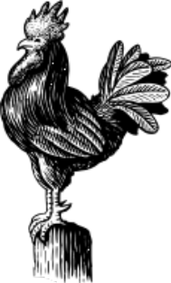

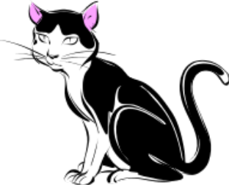





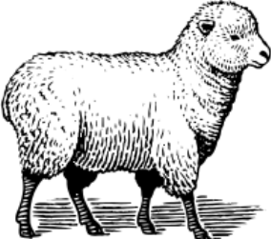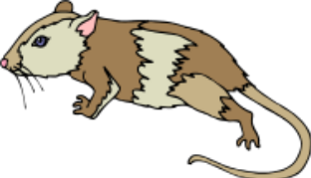

Activity Illustrations



