Grade 2 Theatre Lesson #2
RETELLING STORIES
Character Study
Lesson-at-a-Glance
Warm Up
Generate a class list of people who do certain jobs (gardener, cowboy, teacher, infant, toddler etc). As a group discuss what those characters would look like and how they would move and create movement for two.

Modeling
Refer to the “Three Pigs” from lesson #1. Discuss the characters in detail. Determine what they would look and move like. As a group or in smaller groups, create movement for each of the characters. Add voice if desired.

Guided Practice
Distribute “Character Flash Cards” and create gestures, movement and facial expression for that character. The actor’s ability to effectively show character will be determined by the audience’s ability to identify the character.

Debrief
As a group, chart some of the ways actors show character. Distribute Character Analysis Template. Discuss in your group the characteristics (large, small, facial expression, emotional, feelings, voice and gestures) of one character from your story map. Fill in the template and attach to story map from lesson #1.

Extension
Develop a series of drawings of characters for your story map. Describe the drawings by writing a descriptive word, sentence or paragraph (depending on student readiness) underneath the drawing.

Materials

Character Analysis Template, Character Performance Rubric, Character Flash Cards

Assessment

Discussion, Performance, Q&A, Character Analysis Template and performance rubric

ELA Standards Addressed
Reading Comprehension: 2.5 Restate facts and details in the text to order and clarify ideas
Literary Response: 3.1 Compare and contrast plots, settings, and characters presented by different authors.
Speaking Applications: 2.1 Recount experiences or present stories: b. Describe story elements (e.g., characters, plot, setting).
THEATRE – GRADE 2
Retelling Stories

Character Study
Lesson 2

Content StandardS
2.2 Retell familiar stories, sequencing story points and identifying character, setting, and conflict.
4.2 Respond to a live performance with appropriate audience behavior.

topical QuestionS
- What is “Character Analysis” and how do I analyze a character in a story?
- How do I use by body and face to create a character that is clearly identified by an audience?

Objectives & Student Outcomes
- Students will demonstrate understanding of characterization by performing improvisations and writing a character analysis.

ASSESSMENT (Various strategies to evaluate effectiveness of instruction and student learning)
- Feedback for Teacher
  - Character Performance Rubric (included)
  - Student response to inquiry
  - Character Analysis Worksheet (included)
- Feedback for Student
  - Teacher feedback
  - Peer Feedback
  - Character Performance Rubric
  - Character Analysis Worksheet

WORDS TO KNOW
- audience: people who watch, listen and respond to live theatre
- character: personality or part an actor recreates
- characterization: The development and portrayal of a personality through thought, action, dialogue, costuming, and makeup.

Materials
- “Who Are You” character cards: (illustrations attached)
- Character Analysis Template (included)
- Character Performance Rubric
- CD Player (optional)
- CD “Ready, Set, Move” (optional)

Resources
- Ready, Set, Move!, by Greg and Steve; “Ready, Set, Move”

Warm Up (Engage students, access prior learning, review, hook or activity to focus the student for learning)
- Ask students to think of jobs people do and generate a class list of titles (gardener, cowboy, teacher, firefighter, artist, singer, police officer, clown, car repairman, sales or store clerk, lifeguard, dancer, actor, pilot, infant; ages and stages: infant, toddler, teenager, old person, etc.)
- As a group discuss what those characters would look like and how they would move. Create movement for one occupation and one “age stage” characters.
- Option: As a group, act out the instructions in a musical selection. Suggested Music: “Ready, Set, Move”

Modeling (Presentation of new material, demonstration of the process, direct instruction)
- Refer to story map from lesson 1 “The Three Pigs”.
- Discuss the characters and what they would look and move like. Come up with as much detail as possible: size, shape, voice, clothing worn, facial expression, emotions, feelings, gestures, etc.
- As a group or in smaller groups, create movement for each of the characters.
- If desired, add voice for the characters.

Guided Practice (Application of knowledge, problem solving, corrective feedback)
- Create gestures, movement and facial expression for a variety of characters
- Each student selects a character card (don’t let anyone see your card!).
- Give students about 15 seconds to think about how this character would move and present themselves.
- Arrange students into four or five groups. Each group takes a turn performing while the rest of the class watches.
- When the word action is said, the first group moves silently around the room acting like the character card chosen. Allow 30 seconds of demonstrating.
- Stop action by using the word freeze and ask the audience who the characters were and how they knew (give details about how the character moved).
- (Suggestion: audience only has three chances to guess the character. If the character is not guessed, then the actor will share who their character was.) Ask the audience “What could the actor have done to make that character more clear?”
- Repeat until all groups have had a chance to perform.
- Option: Allow students to speak suitable lines or use vocal sounds.

Debrief and Evaluate (Identify problems encountered, ask and answer questions, discuss solutions and learning that took place. Did students meet expected outcomes?)
- Chart some of the ways actors show character. (E.g., gestures and facial expression to show emotions, feelings, by using speed, shape, voice, etc.)
Further work on Story Map from Lesson 1:
- Distribute Character Analysis Template.
- Discuss in your group the characteristics (large, small, facial expression, emotional, feelings, voice and gestures) of one character from your story map. Note Explore movement ideas for the characters.
- How is the character feeling?
- How fast or slow will the character move and why?
- What is the age of the character?
- What the character would be wearing (costume)?
- What kind of prop could the character be carrying or using?
- Attach the template to your story map.

Extension (Expectations created by the teacher that encourages students to participate in further research, make connections and apply understanding and skills previously learned to personal experiences.)
- Develop a series of drawings of characters for your story map.
- Describe the drawings by writing a descriptive word, sentence or paragraph (depending on student readiness) underneath the drawing.
- Create characterizations.

Character Performance Rubric

4 Advanced: Actor’s gesture, movement and facial expression (and voice if used) is clear and exaggerated. The audience can quickly identify the character.
3 Proficient: Actor’s gesture, movement and facial expression is sufficient for audience to identify the character after thinking or a single incorrect answer.
2 Basic: Actor’s expression of character is not clear and audience has difficulty identifying the character. Student needs coaching but can make changes to make character more clear.
1 Approaching: Actor cannot express character with face and body without assistance. Audience cannot identify the character.

Name | Character | Performance | Comments
 |  | 4 3 2 1
 |  | 4 3 2 1
 |  | 4 3 2 1
 |  | 4 3 2 1
 |  | 4 3 2 1
 |  | 4 3 2 1
 |  | 4 3 2 1
 |  | 4 3 2 1
 |  | 4 3 2 1
 |  | 4 3 2 1
Character Card Illustrations

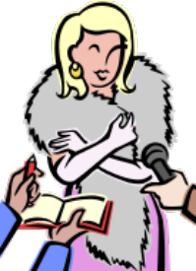

King Queen Karate Expert Movie Star

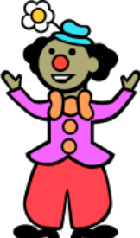

Secret Agent Super Hero Baby Clown

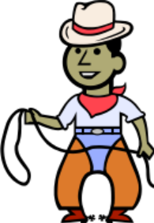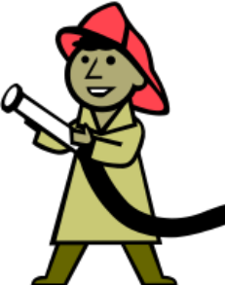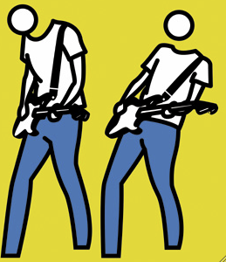

Cowboy Police Officer Fire Fighter Rock Star

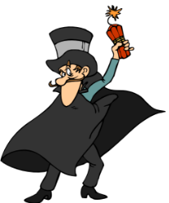

Baseball Player Soccer Player Football Player Villain

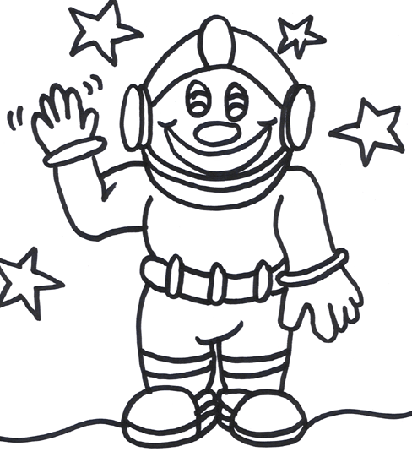
Robot Dancer Spaceman Tightrope Walker

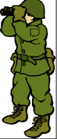

Doctor Artist Soldier Fisherman

Character Analysis Template

YOUR NAME_______________ CHARACTER’S NAME_________________
1. What is the age of your character?

2. Describe your character’s personality.

3. Describe the character’s physical features. Include costume, hair, beard, etc. You may draw a picture or cut one out of a magazine.

4. Describe your character’s personality.

5. Describe an event in your story that is important to the character

