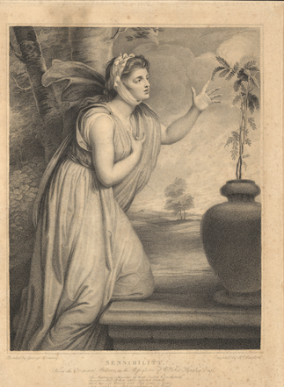
Sensibility. Painted by George Romney. Engrav'd by R. Earlom. From the original picture in the possession of William Hayley, Esq. The leaves, as conscious of their queen's command, Successive fall at her approaching hand; While her soft breast with pity seems to pant, and shrink at every shrinking of the plant. Triumphs of temper Canto V, verse 227

