Points to Ponder on Pope’s “Epistle to Burlington”

This poem, originally titled “Of Taste,” and later titled “Of the Use of Riches,” is addressed to Pope’s friend, Richard Boyle, the Earl of Burlington, who revived the works of Andrea Palladio in his architecture. In this poem Pope tries to define good taste, describing along the way some of the features of Burlington’s Palladian architectural style. He also touches on the new, more modest landscaping style that was favored by members of Pope’s Tory circle.

We’ll discuss the architecture further in class, but it’s useful to take a look at Burlington’s Chiswick House, below, so you know what Palladian architecture looks like.

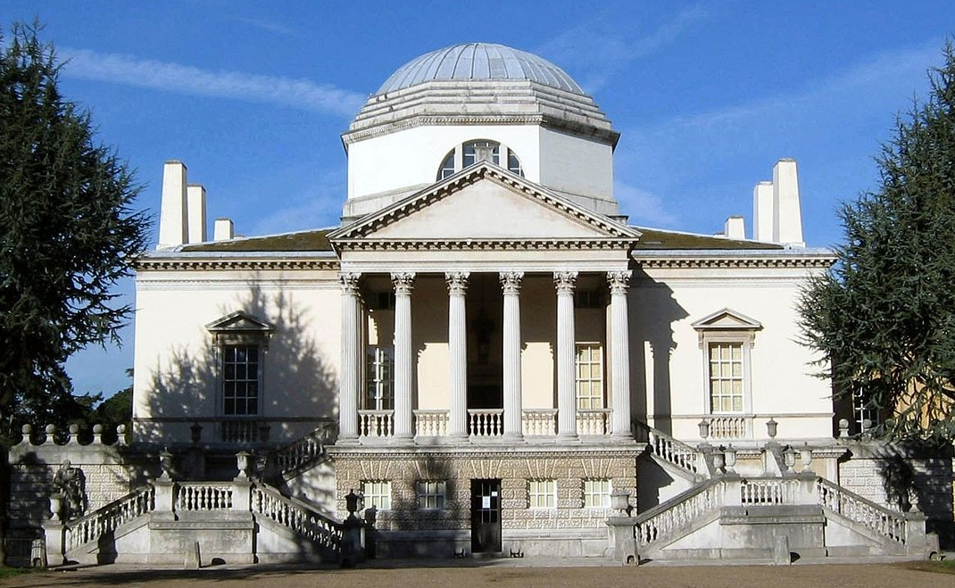

How might you characterize such a building? Does it remind you of buildings you’ve seen before? What kind of impression on the viewer or guest would you assume its builder/owner is trying to make? Does the building have any features that remind you of Pope’s poetry?

In the latter part of the poem, Pope turns to consider (estate) landscaping. Based only on what he says, which of these landscapes would you expect him to prefer?

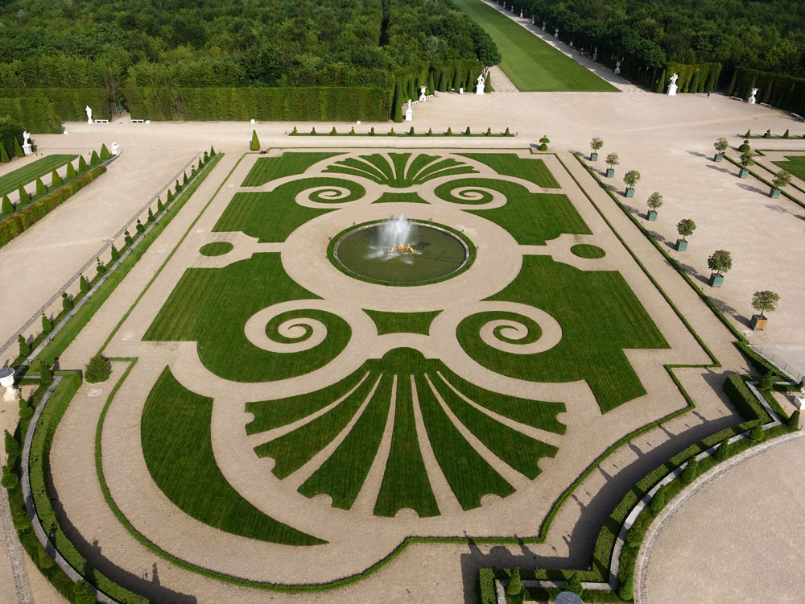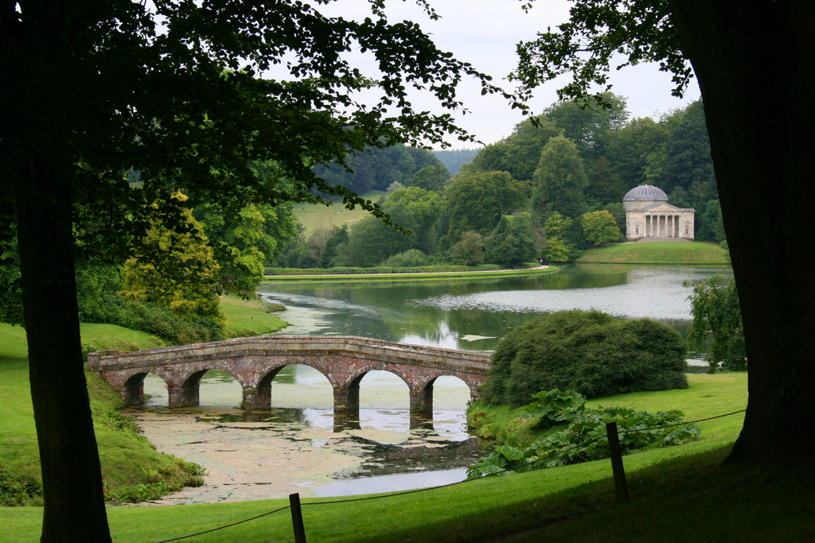

What might you deduce from the fact that Pope is writing a poem on taste in the first place? Under what social circumstances would someone complain about the bad taste of others?

What do you make of the fact that Pope frames this poem as an “epistle,” or letter? What are the implications of his presenting his ideas as if in a letter to a friend?

