Points to Ponder on Richard Payne Knight’s “The Landscape”

Your reading is an excerpt from a late-eighteenth-century poem on estate landscaping. Knight is considered to be one of the major theorists of the picturesque style in landscaping, and his poem had for a frontispiece these two images, dramatizing the shortcomings of “modernization,” i.e., making landscapes in the style of the English Landscape Garden.

Plate 1:
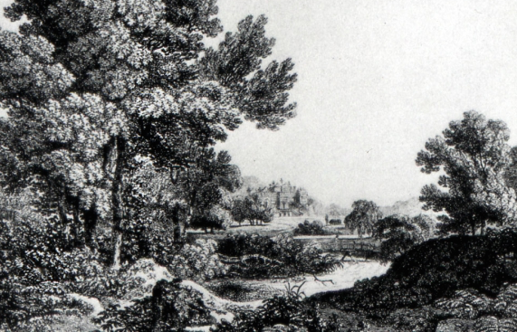

Plate 2:
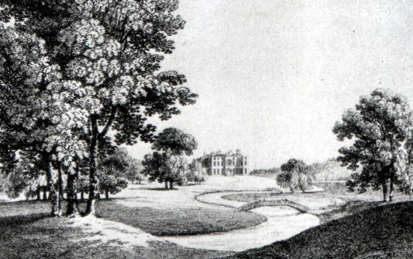
You’ll notice that Knight spends more time bemoaning the fashion for the English Landscape Garden (ELG)—the kind of garden Pope favored—than he does advocating for a “new” style. To track his argument, keep in mind that what he calls the “old system” is the style of the formal garden, associated with French and Italian baroque taste, while “modernizers” and “improvers” are landscape designers who make estate grounds over into the English Landscape style. (Look back at the Points to Ponder for “Epistle to Burlington” to refresh yourself on the difference between baroque gardens and the ELG.) In lines 17-28 Knight notes that formal gardens were typically most formal near the house, while the ELG shapes every part of the grounds.

--Annotate your copy of the poem, highlighting features Knight associates with the old system in one color, and those he associates with the ELG in another.

--Knight often uses political metaphors to condemn landscape features he does not like; what do those metaphors suggest about his politics and the politics of landscape?

--Clearly, Knight does not share Pope’s opinion of the ELG, but are there features of his argument or poetry that remind you of Pope?

