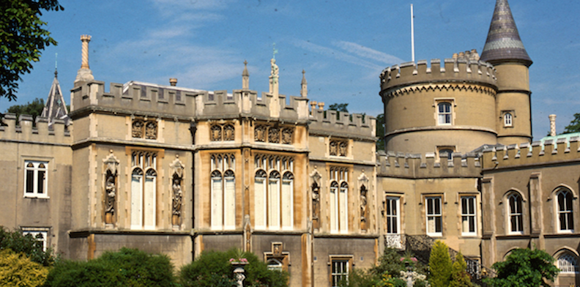

Points to Ponder on Walpole’s Castle of Otranto

This novel is traditionally considered the first gothic novel in English.

--If Pope were to write a novel, can you conceive him writing one like this? Why or why not?
--In the prefaces to the book Walpole discusses its relation to earlier romances; how does he describe that relationship? What English author does he use to justify some of his own authorial decisions?
--How would you describe characterization in the novel? In other words, how and what do we learn about the characters? What seems to matter about them? How individualized are they? How much access do we have to their inner thoughts? Do they “develop” over the course of the narrative? What does their manner of speech say about them?
--What do you make of the fact that Conrad is crushed by an enormous helmet while Theodore is kept inside it?
--How would you describe the relation of the past to the present in this novel?
--Near the end of the novel, one of the servants refers to a “strange revolution.” What sort of “revolution” do we ultimately have here?

