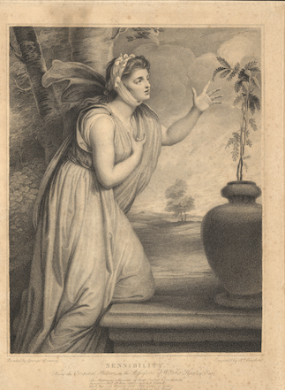

Points to Ponder on Jane Austen’s Sense and Sensibility

What do you make of the way the novel opens?
What does that opening suggest about what matters in the world of the novel?

How are new characters typically introduced into the narrative?
When are Marianne and Elinor introduced?
What do you make of the fact that the novel doesn’t begin with them?

What do the two sisters look like, and what are their accomplishments?
Are those facts in conformity with what we know of their characters?

There are many pairs in the novel besides Elinor and Marianne; list some. How would you characterize the pairings you found?

In what ways does Willoughby’s introduction to Marianne suit his character/role in the narrative?

Why is it fitting that Marianne gets sick?
What might her illness signify?

