Points to Ponder on John Keats’s odes

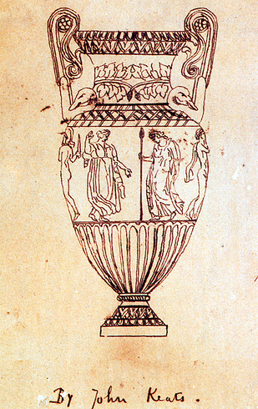

What might it mean to address a poem to something or someone?
Why select each of these particular persons/things as subjects for an ode?
What does each subject seem to represent to the speaker?

All of these odes address persons or things as if they were persons. What are the implications of this?

How does the speaker understand his relationship to the subjects of these poems? Does that relationship change over the course of the poem?
Does the speaker seem, by the end of the poem, to be changed in some way?

