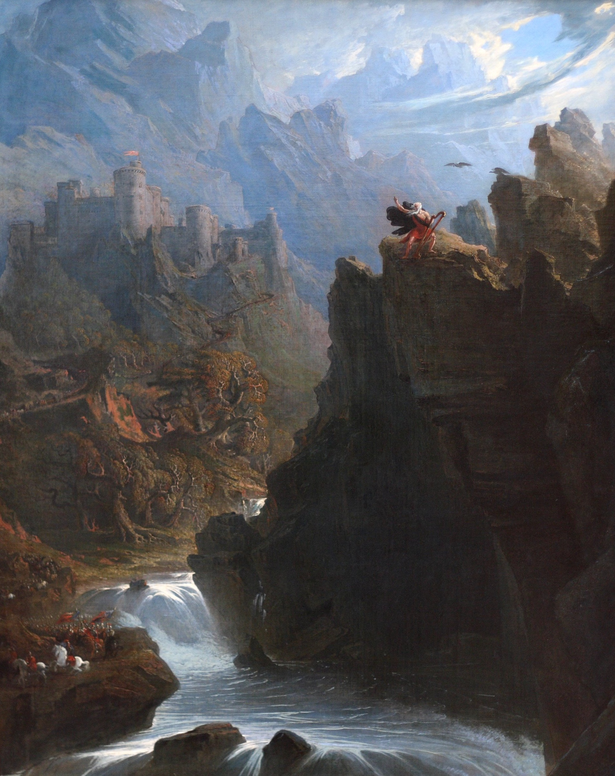

Points to Ponder on Burke’s
Enquiry into the Origin of Our Ideas on the Sublime and Beautiful

Burke’s treatise appeared in 1757, and although inspired by Longinus’ formulation of the sublime, it understands the etiology and significance of the sublime rather differently from Longinus (Kant, too, will later develop yet another account of the sublime). Bear in mind that as an eighteenth-century writer Burke had to develop his ideas in a context in which the beautiful was commonly regarded as the only aesthetic category.

1) How does Burke account for the existence of the sublime? Is it a personal/idiosyncratic response to certain objects? Does it originate in the structure of the perceiving mind or in the objects of perception?

2) List some of the characteristics Burke associates with sublime things. What are some examples he gives of sublime objects and animals? What kind of person might be considered sublime?

3) Burke spends a considerable amount of time talking about things that are not the cause of beauty; what are some of those things?

