Points to Ponder on De Quincey’s Confessions of an English Opium-Eater

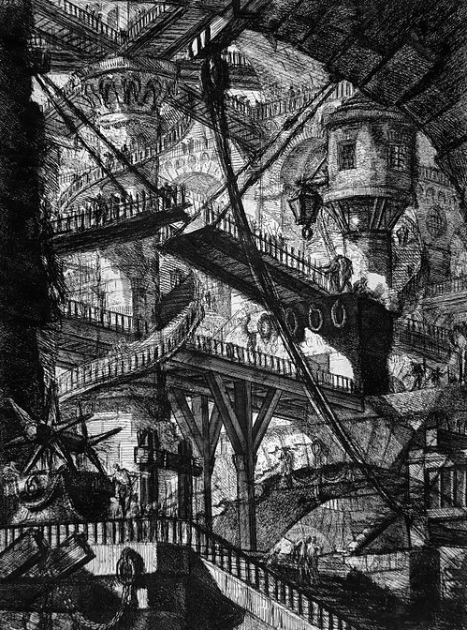
Piranesi, from Le Carceri d'Invenzione

Look closely at the first section, “To the Reader.” How does it seem that De Quincey feels about writing up these “confessions”? Is he ashamed of his addiction or his publicizing of it? Does he claim that his story will have a moral? Do you think it ultimately does?

At those moments when the speaker mentions his readers (or addresses readers directly) how does he implicitly or explicitly characterize them?

Why does the speaker talk as much as he does about his skill in Greek?

How does the speaker compare opium to alcohol?

What is the speaker’s class, and how does he relate to people from other classes?

What are some of the implications of the scene with the Malay?

As you read, pay attention to the organization of the book. What do you notice about the way it is structured? Although it is autobiographical, this is not a straightforward autobiography; what can you say about what the speaker has decided to recount and what he has decided to leave out?

