Points to Ponder on Reynolds’ “Discourse III,” Blake’s annotations to the “Discourse,” and Blake’s poetry

In 1769 artists convinced King George III to establish a Royal Academy of Arts—a national institution for training artists and exhibiting their work. Reynolds was the first President of this Academy, and gave a discourse, or lecture, each year at the annual prize-giving ceremony.

--What is Reynolds’ attitude toward “nature”? Is it the task of the artist to copy it
faithfully?
--Do you see any indications that Reynolds hopes to raise the social status of
painters?
--Is there a historic period or style of art that he would have his students emulate?
--What kind or genre of painting does Reynolds admire most? Why?
--How do Reynolds and Blake differ in their account of genius?
--What seems to be Blake’s attitude toward institutions?
--What is the status of the individual person or the particular detail in Reynolds’ essay? In Blake’s writings?

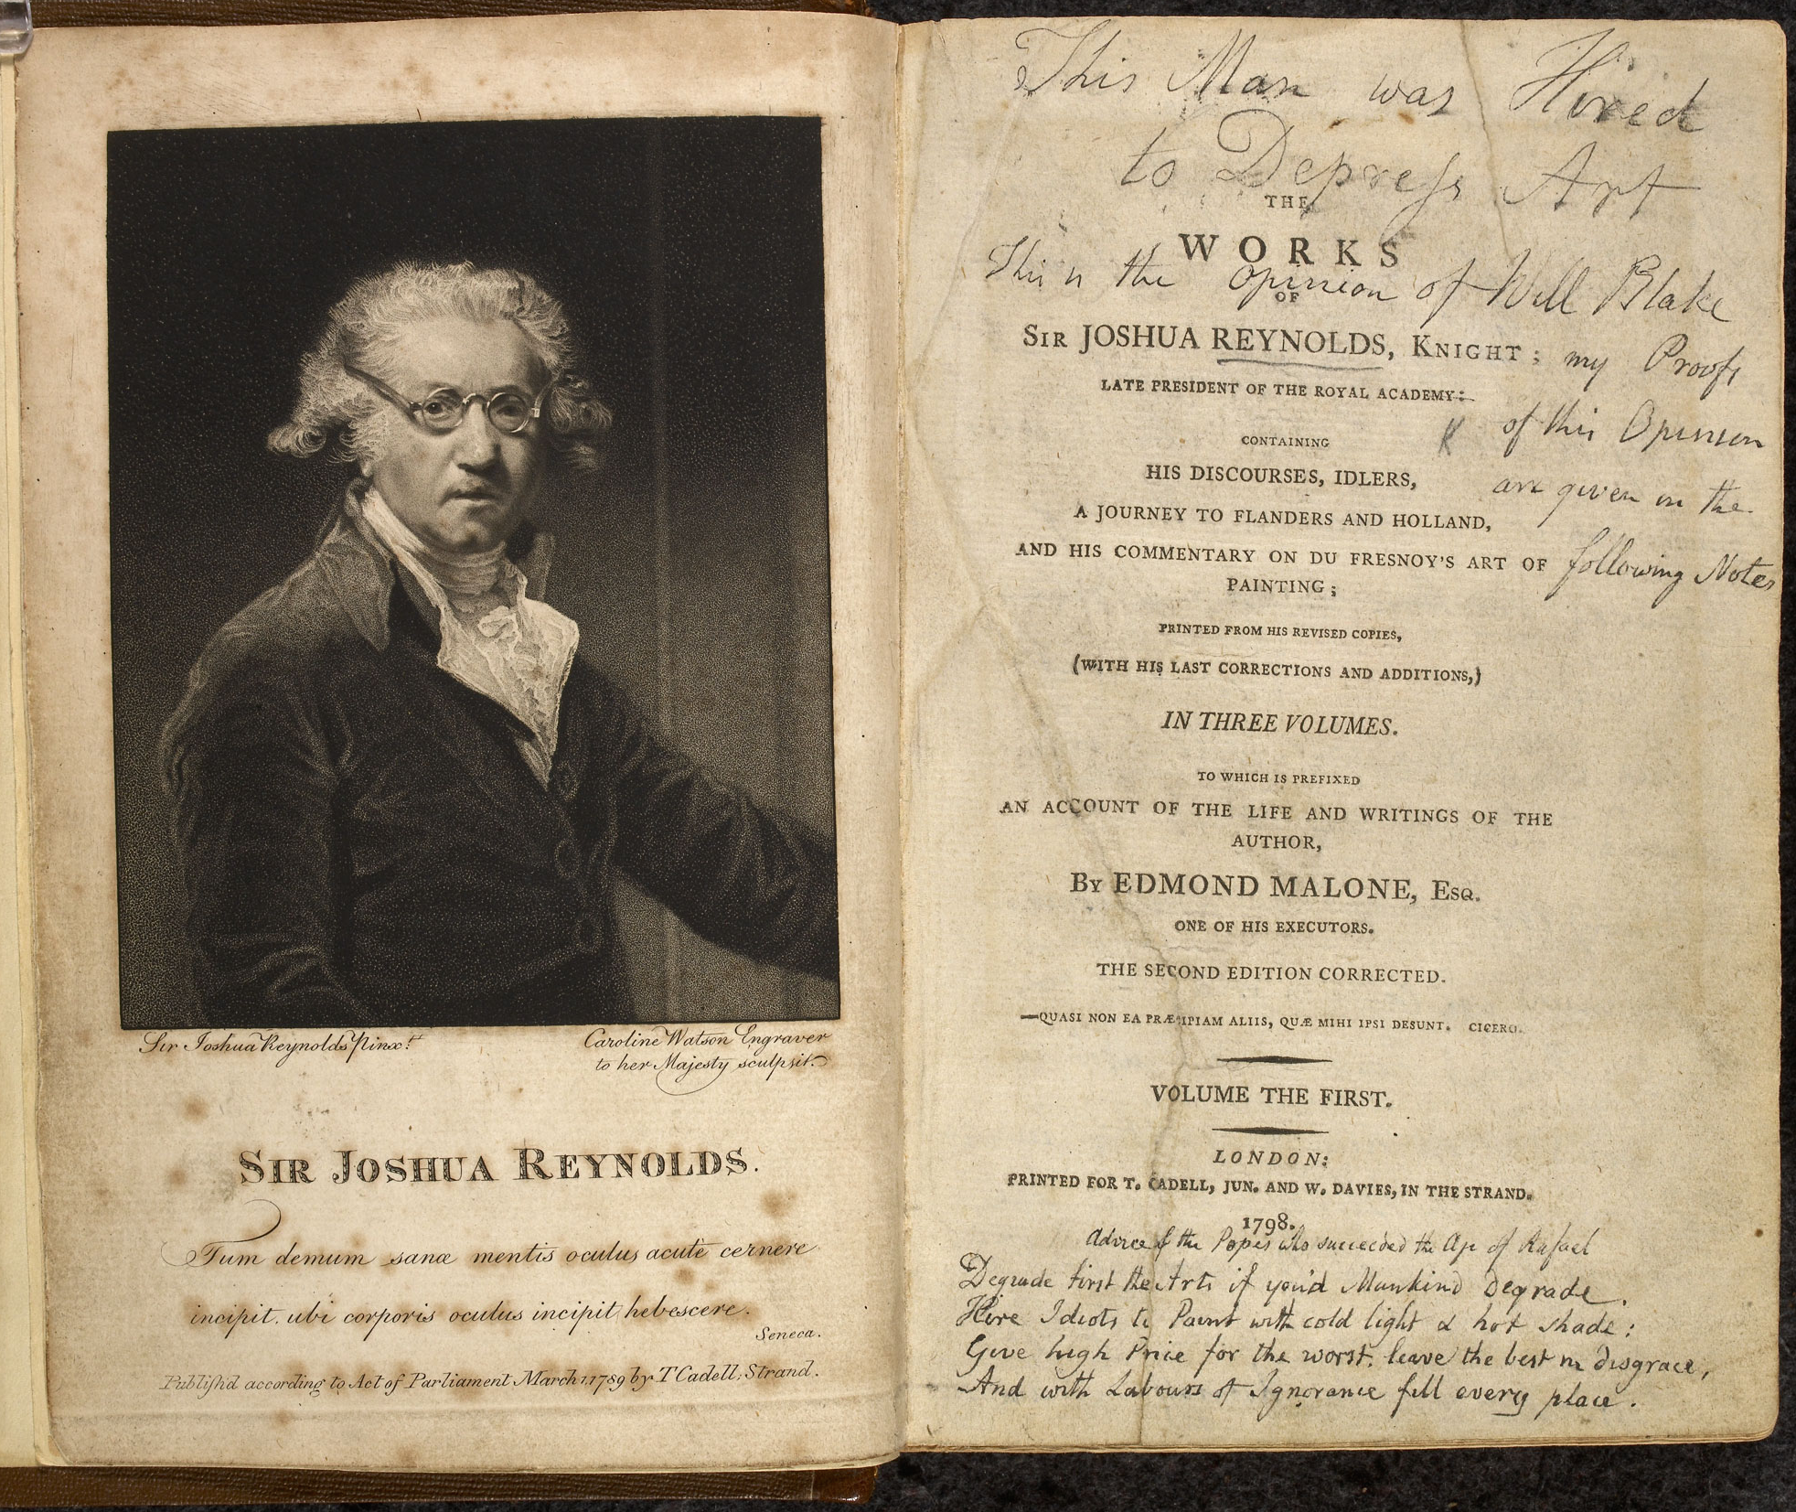

Frontispiece of Blake’s copy of Reynolds’ Works

