Hand gesture exercise

During the eighteenth century, posture, gesture, and even expression were codified, taught, and practiced. As you will see below, the hands alone were considered very expressive and were the subject of entire volumes. Your task will be to perform a portion of The Beggar’s Opera, focusing particularly on the use of eighteenth-century gestures to express the characters’ emotions. You will use the information below as a guide. Do not feel that you have to study every gesture; you can scan the charts to find gestures relevant to your scene. You do not have to memorize your lines, and you may speak the songs rather than singing them, but be sure all members of the group understand the scene and the lines they say. The acting might not be Oscar-level, but the lines should be spoken with understanding. After the performance, each person will explain the gestures they used and why they used them. In addition to the performance, each student will hand in a 1-page paper detailing his or her plan for performing the scene.

From Courtney Crouse, “Capturing the Affections”

Bulwer’s Chirologia and Chironomia and Gilbert Austin’s Chironomia give us a
vivid picture of the common gestures of the Restoration era and the century that
followed.

John Bulwer’s Chirologia and Chironomia provide explicit explanations and
pictorial representations of common seventeenth-century gestures. In the first set of
gestures in figure 23, it is striking that they are so commonsensical. To entreat, to plead,
to pray, to worry, to invite, etc., are all recognizable and conventional gestures. Letter F,
the gesture for indignance, is made by a slap to the left hand. What should be noted is the specificity of slapping the left hand. The left hand was considered the weaker hand in ancient times through the Restoration and beyond. Bulwer explains that “the
left hand of itself alone is most incompetent to the performance of any perfect action;
yet sometimes it doth, but very rarely. . . . where both hands concur to any action, they
exhibit more affection.” Gesture Y in figure 5 indicates thievery. In the Restoration
era, anything evil or underhanded would have been done with the left hand as much as
possible. The left hand was also used to express an aversion to something or someone and would be used in all gestures of disparagement. In a comparison of good and bad, the good would be emphasized with the right hand and the bad emphasized with the left.
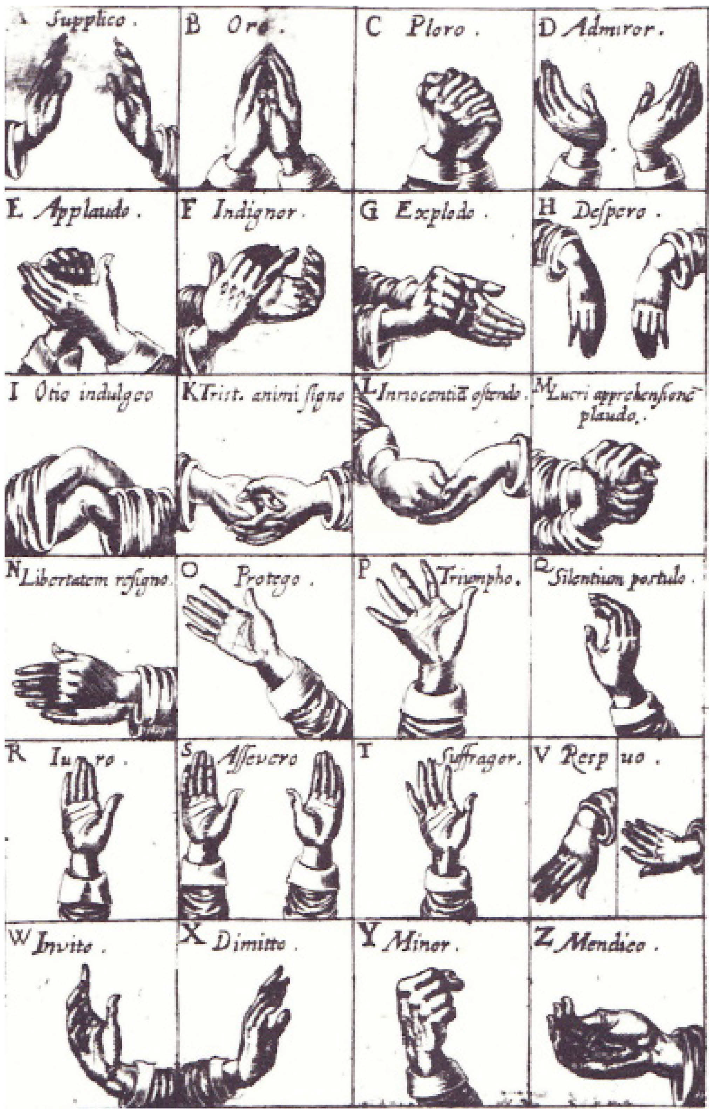Figure 23. Chirogrammatic Plate A

Bulwer’s explanations of figure 23:

A: Gestus I: Supplico [I entreat]
The stretching out of the hands is a natural expression of gesture, wherein we are significantly importunate, entreat, request, sue, solicit, beseech and ask mercy.
B: Gestus II: Oro [I pray]
To raise the hand conjoined or spread out towards heaven is the habit of devotion, in a natural and universal form of prayer practiced by those who are in adversity and in bitter anguish of mind, and by those who give public thanks and praise to the most high.
C: Gestus III: Ploro [I weep]
To wring the hands is a natural expression of excessive grief used by those who condole, bewail, and lament.
D: Gestus IV: Admiror [I admire]
To throw up the hands to heaven is an expression of admiration, amazement, and astonishment, used also by those who flatter, and wonderfully praise, and have others in high regard, or extol another’s speech or action.
E: Gestus V: Applaudo [I applaud]
To clap the raised hands one against another is an expression proper to them who applaud, congratulate, rejoice, assent, approve, and are well-pleased.
F: Gestus VI: Indignor [I am indignant]
To smite suddenly on the left hand with the right is a declaration of some mistake, dolour, anger, or indignation.
G: Gestus VII: Explodo [I explode (in anger)]
To clap the right fist often on the left palm is a natural expression used by those who mock, chide, brawl, and insult, reproach, rebuke and explode, or drive out with noise, commonly used by the vulgar in their bickerings.
H: Gestus VIII: Despero [I despair]
To appear with fainting and dejected hands is a posture of fear, abasement of mind, and abject and vanquished courage, and of utter despair.
I: Gestus IX: Otio indulgeo [I indulge in ease]
To fold the hands is a gesture of idleness.
K: Gestus X: Tristem animi recessum indico [I show mental anguish]
To hold the fingers inserted between each other across is their sluggish expression who are fallen into melancholy muse.
L: Gestus XI: Innocentiam ostendo [I display innocence]
To imitate the posture of washing the hands by rubbing the back of one in the hollow of the other with a kind of detersive motion is a gesture sometimes used by those who would profess their innocency and declare they have no hand in that foul business, not so much as by their manual assent, as it were, assuring by that gesture that they will keep their hands undefiled and would wash their hands of it, not have anything to do therein.
M: Gestus XII: Lucri apprehensionem plaudo [I applaud the taking of money]
To rub the palms of the hands together, with a kind of applause, much after the manner as some are wont to do who take pains to heat their hands, is an itching note of greedy haste.

N: Gestus XIII: Libertatem resigno [I resign my liberty]
To hold forth the hands together is their natural expression who yield, submit, and resign up themselves with supplication into the power of another.
O: Gestus XIV: Protego [I protect]
To extend out the right hand by the arm foreright is the natural habit wherein we sometimes allure, invite, speak to, cry after, call, or warn to come, bring into, exhort, give warming, admonish, protect, pacify, rebuke, commend, justify, avow, inquire, direct, instruct, order, show a generous confidence, hardiness, and authority; give free liberty of speech, manifest a readiness to answer, and make an apology for ourselves, and appear to undertake business.
P: Gestus XV: Triumpho [I triumph]
To put out the raised hand, and to shake it as it were into a shout is their natural expression who exhalt, brag, boast, triumph, and by exultant gesture express the raptures of their joy; they also who would declare their high applause, or would congratulate, and they who have drunk do commonly use the same gesture.
Q: Gestus XVI: Silentium postulo [I demand silence]
The beckoning with the raised hand hath been ever with all nations accounted a sign of craving audience and entreating a favorable silence.
R: Gestus XVII: Juro [I swear]
To lift up the right hand to heaven is the natural form and ceremony of an oath, used by those to call God to witness and would adjure, confirm, or assure by the obligation of an oath.
S: Gestus XVIII: Asserveratione Deum attestor [I call God to witness]
To extend and raise up both the hands to heaven is an expression of establishment and a most strong kind of asseveration implying as it were a double oath.
T: Gestus XIX: Suffragor [I permit]
To hold up the hand is a natural token of…consent, election, and of giving Suffrage.
V: Gestus XX: Respuo [I reject]
The flirting out of the back part of the hand or put-by of the turning of the palm is their natural expression who would refuse, deny, prohibit, repudiate, impute, or to lay to one’s charge, reject or pretend to lay for an excuse, or would twit and hit one in the teeth with a thing, and signify disdain.
W: Gestus XXI: Invito [I invite]
To show forth the hand, and so forthwith to call back, as it were and bring it again unto us with a waving motion is a natural gesture and a vulgar compellation which we significantly use in calling for men whom we bid come near and approach unto us.
X: Gestus XXII: Dimitto [I dismiss]
To wag and wave the hand from us is an expression by gesture significant to prohibit, bid one be gone, keep off, forbid, dismiss, and bid farewell and adieu.
Y: Gestus XXIII: Minor [I threaten]
To show and shake the bended fist at one is their habit who are angry, threaten, would strike terror, menace, revenge, show enmity, despite, contemn, humble, challenge, defy, express hate, and offer injury, tell one what he must look for at their hands…
Z: Gestus XXIV: Mendico [I beg]
To put forth the right hand spread is the habit of bounty, liberality, and a free heart; thus we reward and friendly bestow our gifts…

All of Bulwer’s gestures are named as actions; in the next set of gestures, action is
even more significant as many of them involve another person. Gesture P, Conscienter affirmo, illustrates a graceful hand that would then be placed on the heart accompanied by a little bow when affirming something or swearing it to be true. This is a highly formal gesture that is not customary today. Gesture S, in figure 27, is another slightly uncommon gesture which is designated for striking an agreement. Today we would “shake hands on it,” but Bulwer indicates that there is only a mere slapping together of the hands. In Gestus XL, Faveo, meaning, “I favor,” Bulwer describes how a person behaves when they feel lovingly toward another: “We use to stroke them gently with our hand whom we make much of, cherish, humor, or affectionately love, an expression very obvious among the actions of common life being a kind of indulgent declaration of the mind used to pacify and please other, performed by drawing our hand with a sweetening motion over the head or face of the party to whom we intend this insinuation.”
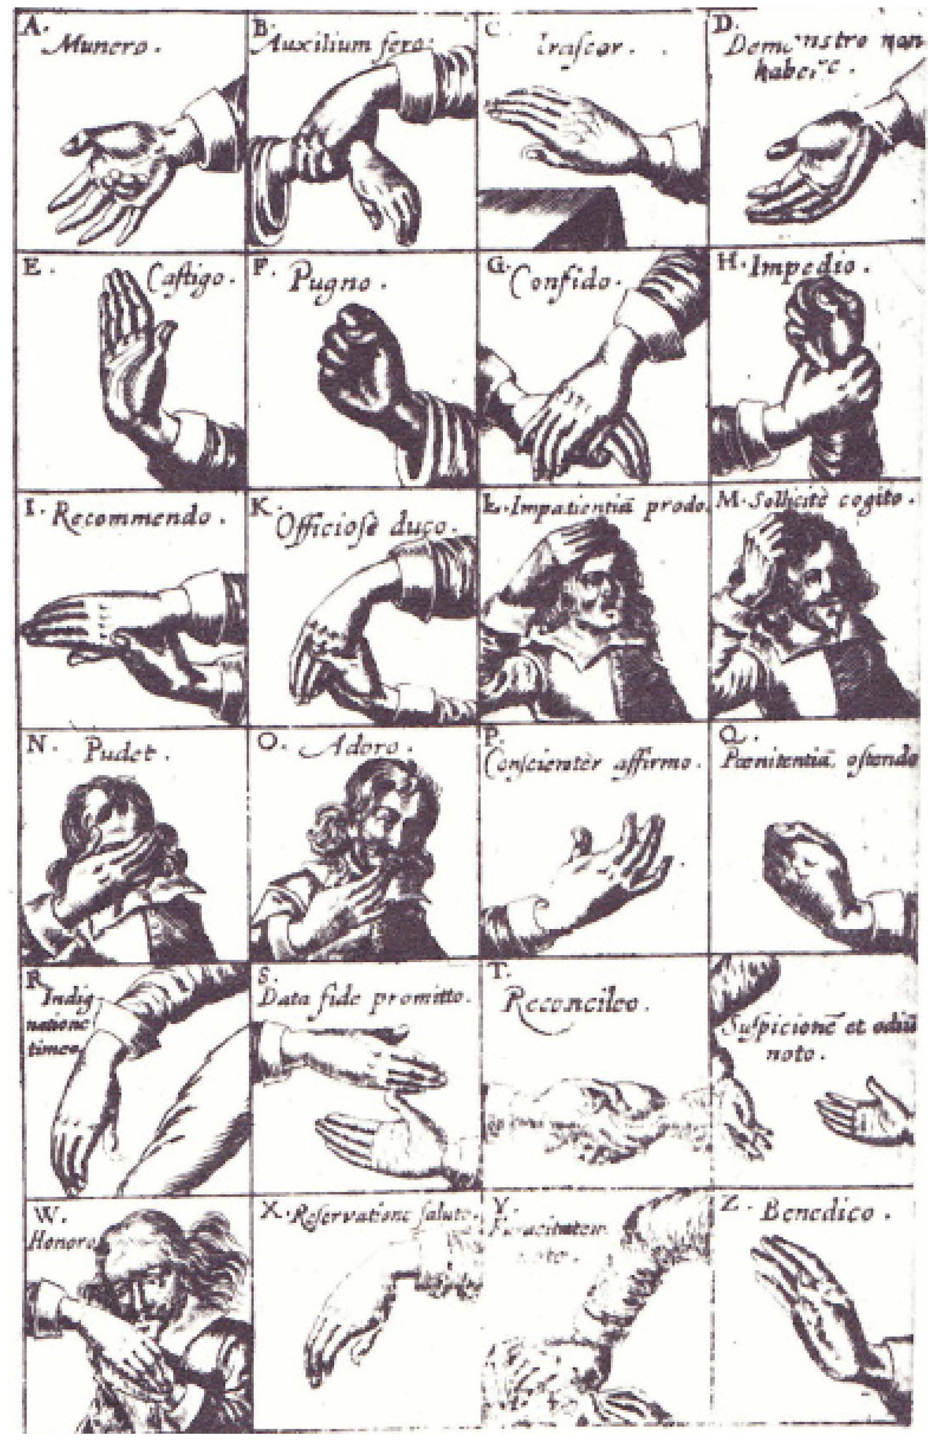
Bulwer’s explanations of figure 27:

A: Gestus XXV: Munero [I reward]
To put forth the right hand spread is the habit of bounty, liberality and a free Heart.
B: Gestus XXVI: Auxilium fero [I bring aid]
To extend and offer out the right hand unto any is an expression of pity and of intention to afford comfort and relief, used also as a token of assurance, peace, security, and promised safety, and salvation.
C: Gestus XXVIII: Irascor [I am angry]
To strike a table or some such like thing with the hand is the gesture of one angry or grieved in mind and very impatient.
D:Gestus XXXIII: Demonstro non habere [I show I do not have]
To shake out the hand is their natural expression who would show that they have
not, nor desire to have a thing.
E: Gestus XXXIV: Castigo [I chastise]
To shake or hold the stretched and raised hand over any is their expression who
offer to chastise and show a willingness to strike or take revenge.
F: Gestus XXXV: Pugno [I fight]
To strike one with the fist is their gesture who would be avenged of those that have offended them and would right themselves in this wild justice of their hands.
G: Gestus XLII: Confido [I confide in]
To lean upon another’s hand is their gesture who make a confiding use of the staff of their age or affection, an expression importing that they much rely upon their faith and friendship.
H: Gestus XLIII: Impedio [I impede]
To hold fast another’s hand in the signification of hindrance and restraint is the gesture so obvious in the choleric perterbations of human life that it needs no illustration by example.
I: Gestus XLV: Recommendo [I recommend]
To take one by the hand in courtesy to recommend them unto another way by way of presentation.
K:Gestus XLVI: Officiose duco [I lead about in an official capacity]
To lead one by the hand is their expression who take care of the weakness and inability of others in matters of progressive motion used most commonly with young children.
L: Gestus XLVII: Impatientiam prodo [I betray impatience]
To apply the hand passionately until the head is a sign of anguish, sorrow, grief, impatiency, and lamentation used also by those who accuse or justify themselves.
M:Gestus XLVIII: Sollicite cogito [I compel by repeated requests]
To rub or scratch the head with the hand is their natural gesture who are in anguish or trouble of mind; for commonly when we are in doubt and uncertain what we do, we musing scratch our head.
N: Gestus XLIX: Pudeo [I am ashamed]
The recourse of the hand to the face in shame is a natural expression.
O: Gestus L: Adoro [I adore]
To kiss the hand is their obsequious expression who would adore and give respect by the courtly solemnity of a salutation or valediction.
P: Gestus LII: Conscienter affirm [I affirm (my) conscience]
To lay the hand open to our heart using a kind of bowing gesture is a garb wherein we affirm a thing, swear or call God to witness a truth.
Q: Gestus LIII: Poenitentiam ostendo [I display contrition]
To beat and knock the hand upon the breast is a natural expression of the hand used in sorrow, contrition, repentance, shame, and in reprehending ourselves, or when anything is irksome unto us because the breast is the cabin of the heart.
R: Gestus LV: Indignatione timeo [I fear with indignation]
The smiting of the hand upon the thigh in the practice and conversation of common life was ever frequent and is so deeply imprinted on the manners of men that you shall in vain persuade a man angry and enraged with grief to contain his hand from this passion.
S: Gestus LVI: Data fide promitto [I pledge my faith]
To strike another’s palm is the habit and expression of those who plight their troth, give a pledge of faith and fidelity, promise, offer truce, confirm a league, buy, sell, grant, covenant, bargain, give or take handsel, engage themselves in suretyship, refer their controversies to an arbiter, put to compromise or choose an umpire, engage themselves to be true and trusty, warrant and assure.
T: Gestus LVII: Reconcilio [I reconcile]
To shake the given hand is an expression usual in friendship, peaceful love, benevolence, salutation, entertainment, and bidding welcome, reconciliation, congratulation, giving thanks, valediction, and well-wishing.
V: Gestus LIX: Suspicionem et odium noto [I note suspicion and hate]
To draw back the unwilling hand instead of reaching it out to embrace the hand of another is a sign of enmity.
W: Gestus LXI: Honoro [I honor]
To apprehend and kiss the back of another’s hand is their natural expression who would give a token of their serviceable love, faith and loyalty, honorable respect, thankful humility, reverence, supplication and subjection.
X: Gestus LXII: Reservatione saluto [I greet one with reservation]
To offer the back of the right hand to be kissed by others…is an expression of state used by proud and scornful persons who affect the garb of great ones and are willing to afford slight respect to one they think unworthy of a higher touch.
Y: Gestus LXIII: Furacitatem noto [I show thievery]
To put forth the left hand, as it were, by stealth is their significant endeavor who have an intent unseen to purloin and convey away something.
Z: Gestus LXIV: Benedico [I bless]
The imposition of the hand is a natural gesture significantly used in condemnation, absolution, pardon and forgiveness, benediction, adoption, initiation, confirmation, consecration, ordination…and in gracing our meals.

The next set of gestures Bulwer discusses are those performed by precise finger
formations. Gesture I, meaning to disapprove, refute or convict, has no modern equivalent. The index finger curving downward is a gesture of disapproval and is a smaller version of gesture L. Today, gesture L might look like something more vulgar as the index finger begins erect and then goes limp. Even with the modern interpretation, this gesture would be an interesting choice for disapproval, and perhaps, the vulgarity that this gesture implies today was exactly what was indicated in the seventeenth century.
M is somewhat familiar but has evolved in modern times from a pinky scratch to the head to betray coy shame to the pinky in the mouth. Gesture O has also undergone an evolution, shifting from a sideways pointing of the middle finger to a straight up pointing of the middle finger, and it seems that the use of this finger, although used to communicate hate as it is today, was not such an obscene or shocking gesture. Gesture S is a left-handed gesture with the left hand in a fist representing greed. Gesture V is seen on many operatic stages now and in the past: the Claw, which Bulwer describes
aptly as an “impotent expression of a cursed heart.” Gesture W is a very funny gesture
that is not used today in which the thumb and middle fingers are touching while the index
and ear finger, now known as the pinky, are up being wagged at someone who does
something inappropriate or has bad manners. This gesture was also used to indicate a
cuckold. Gesture Z illustrates that counting began with the thumb in the
seventeenth century.

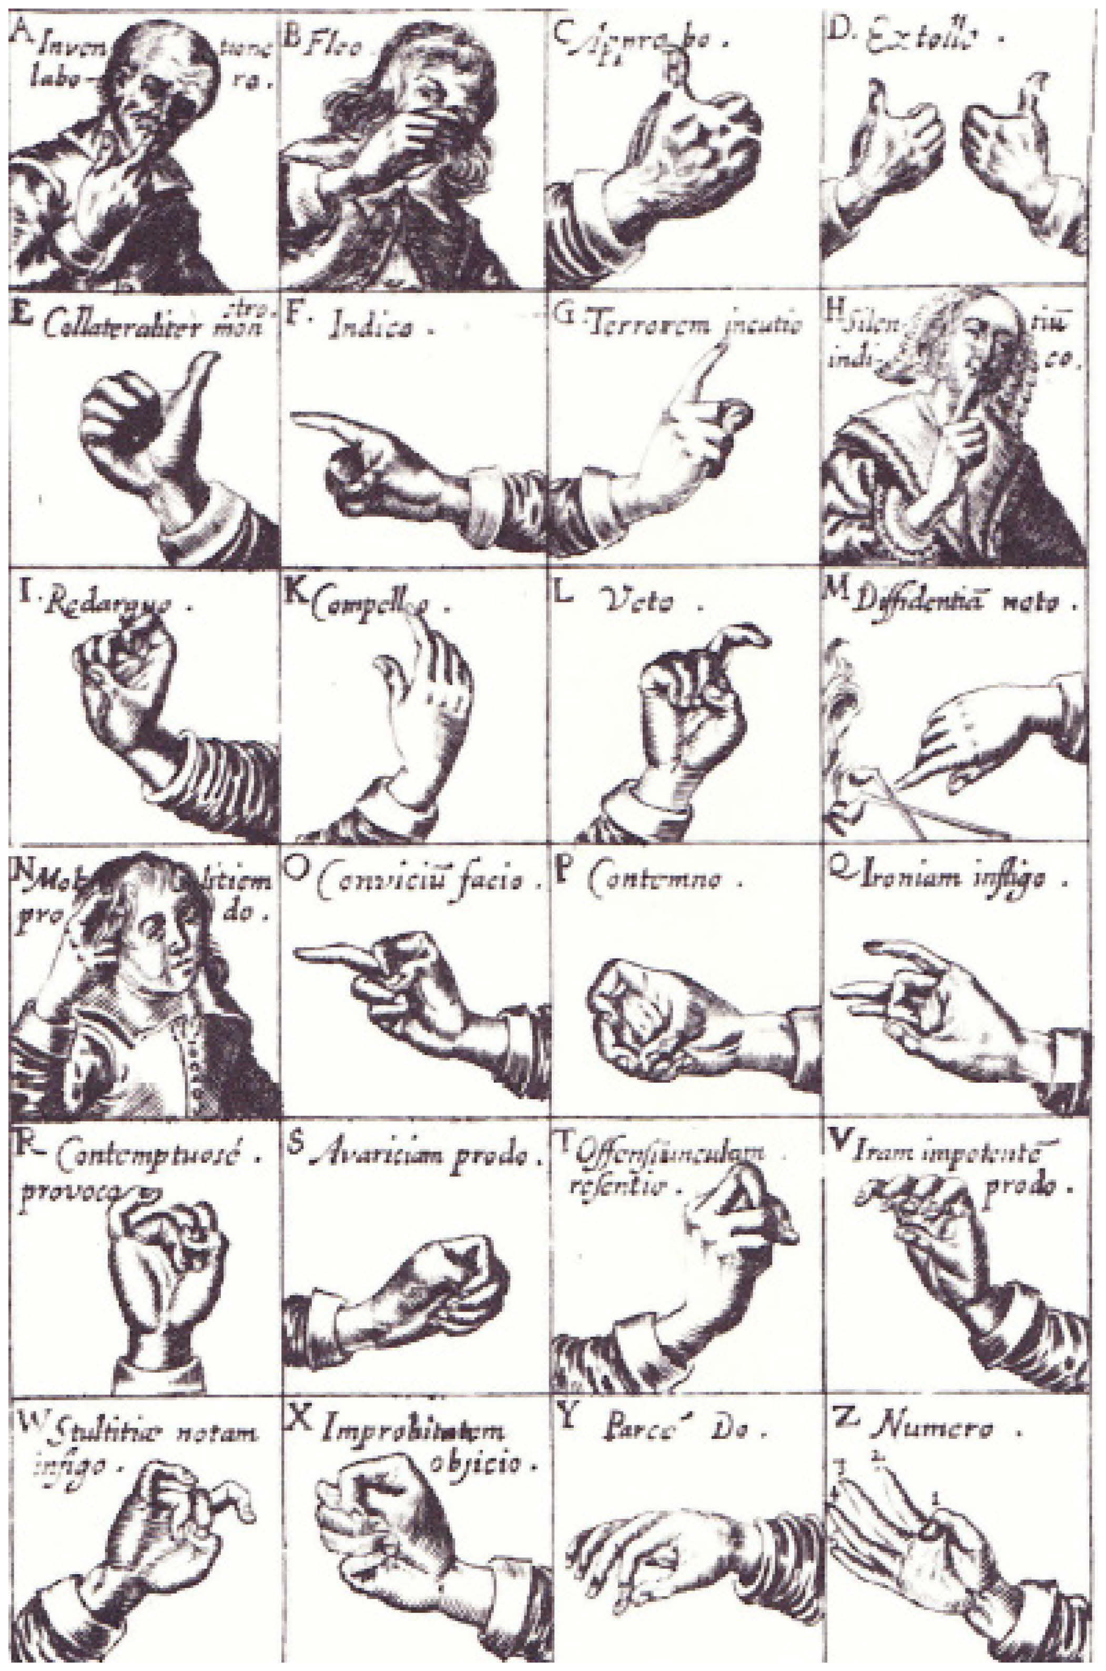
Bulwer’s explanations of figure 28:

A: Gestus I: Inventione laboro [I work in discovery]
The finger in the mouth gnawn and sucked is a gesture of serious and deep meditation, repentance, envy, anger, and threated revenge.
B: Gestus II: Fleo [I weep]
To put a finger in the eye is their expression who cry and would, by that endeavor of nature, ease themselves and give vent to their conceived heaviness.
C: Gestus III: Approbo [I approve]
To hold up the thumb is the gesture of one giving his voice or sufferage, of one that helpeth with his word at the time of election, and of one showing his assent or approbation.
D: Gestus IV: Extollo [I extol]
To hold up both the thumbs is an expression importing a transcendency of Praise.
E: Gestus V: Collateraliter monstro [I show both sides (of an issue)]
To point with the turned out thumb is a note of demonstration.
F: Gestus VI: Indico [I point]
The forefinger put forth, the rest contracted to a fist, is an express of command and direction, a gesture of the hand most demonstrative.
G: Gestus VII: Terrorem incutio [I inflict terror]
The holding up of the forefinger is a gesture of threatening and upbraiding.
H: Gestus IX: Silentium indico [I show silence]
The laying of the forefinger upon the mouth is their habit who would express their silence, conviction, shame, ignorance, reverence, servile fear, modesty, a revolving meditation, admiration and amazement.
I: Gestus X: Redarguo [I reprove]
The bowing down of the forefinger for a check of silence, and the redargue (scold, express disproval of), is an action often found in the hands of men.
K: Gestus XI: Compello [I summon]
The lifting up and bowing of the index towards the face is a usual gesture of Invitation.
L:Gestus XII: Veto [I disapprove]
The raising up and bowing the forefinger from us is a gesture natural to those who beckon a retreat or forbid.
M: Gestus XIII: Diffidentiam noto [I show hesitancy]
To feel with the fingers’ ends is their special expression who endeavor to satisfy themselves by information of the tact in the qualities of a thing.
N: Gestus XIV: Molliciem prodo [I betray weakness]
To scratch the head with one finger is a kind of nice and effeminate gesture betraying a close inclination to vice.
O: Gestus XV: Convicium facio [I provoke (an argument)]
The putting forth of the middle finger, the rest drawn into a fist on each side…is the natural expression of scorn and contempt….fornicator…whoremonger.
P: Gestus XVI: Contemno [I condemn]
To compress the middle finger with the thumb by their complosion producing a sound and so casting out our hand is a gesture we use to signify our contempt of unprofitable things and to show, by gesture, how we slight, contemn, insult, and undervalue anything.
Q: Gestus XVII: Ironiam infligo [I impose irony]
To bend the middle finger while it stiffly resteth upon the thumb, and so jestingwise
to let it off, is a trivial we with a fillip (flicking motion-me) inflict a trifling punishment or a scoff.
R: Gestus XVIII: Contemptuose provoco [I provoke in a contemptuous fashion]
To beckon with the ear-finger is their usual concise expression who are advanced by confidence to rely upon the strength of their ability and would by a provoking signal dare, challenge, defy, and bid one prepare for an encounter, implying a strong presumption of the victory, as if they esteemed him as nothing in their hand.
S: Gestus XIX: Avaritiam prodo [I betray avarice]
To grip the left hand, the thumb clutched in withal, is the hold fast gesture of tenacious avarice.
T: Gestus XX: Offensiunculam resentio [I resent a slight offense]
To give one a rap with the fingers half bent, or [with the] knuckles, is their expression who would vent their slight anger or dislike upon others, or [who] would softly and modestly knock at some door.
V: Gestus XXI: Iram impotentem prodo [I betray a mild anger]
To put the fingers into a grip or claw-like aspect, and to scratch or claw another therewith, is the impotent expression of a cursed heart that eagerly desires to set a mark of displeasure upon those that have provoked it to a splenetic use of its pounces.
W:Gestus XXII: Stultitiae notam infigo [I make the sign of folly]
To present the index and ear-finger wagging, with the thumb applied to the temples, is their expression who would scornfully reprove any for failing in any exercise of wit, or for some absurd stumble of tripping and inconsiderate lip, or for some error in manners and behavior.
X: Gestus XXIII: Improbitatem objicio [I accuse of improbability]
To lock the thumb between the next two fingers is an ironical vulgarism of the hand used by plebians when they are contumeliously (a humiliating insult) provoked thereunto and the see that they cannot prevail by vying words.
Y: Gestus XXIV: Parce do [I give sparingly]
To give with two fingers is a parsimonious expression of the hand often seen in clutch-fists niggards and pinch-pennies from whose gesture the adage came.
Z: Gestus XXV: Numero [I count]
To begin with the first finger of the left hand and to tell on/to the last finger on the right is the natural and simple way of numbering and computation.

A few other gestures useful to the actor are the snapping of fingers and the okay symbol. Bulwer recounts that the snapping of the fingers was prescribed by the ancients to call or get a servant’s attention. It is an arrogant commanding gesture. This is a characteristic gesture that someone of higher rank would use to address an underling.

The middle finger to thumb is a gesture of emphasis that is not uncommon, but the gesture of emphasis that looks like the modern ‘okay’ symbol was described by Bulwer as a gesture to “distinguish or approve.”

Figure 29. Colley Cibber as Lord Foppington

This picture of Colley Cibber performing this gesture as the character Lord Foppington
illustrates that this was a common gesture. That this character was made more foppish by
using this gesture is not clear, but the handkerchief is held very artfully in his left hand.

