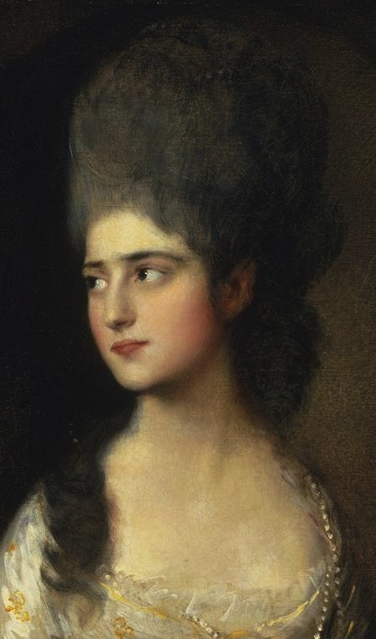

[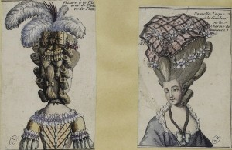](http://demodecouture.com/wordpress/wp-contents/uploads/2011/08/1778_maciet.jpg)